The Task:

A local council has collected a number of datasets detailing traffic flow at road junctions in the area. The data, collected for two junctions (Elm Avenue/Rabbit Road and Hanley Highway/Westway) over a number of days has been tabulated and saved as .CSV files (two are supplied – each one for a particular 24-hour period).

You have been tasked with writing a program which analyses the data and returns data to allow the council to make informed decisions to manage traffic flow. Your program should allow council staff to select any particular CSV dataset file (by date), analyse the data and summarise the specific elements required.

It should also save the results as a text file (Task C) and display the results of some specific analysis in graphical form (Task D: Histogram).

The data structure of the csv files is shown below with each row representing the recording of one vehicle passing through one of the two junctions at a specific time on the selected date (below are two rows as an example, see the CSV files for full data list).

JunctionName | Date | timeOfDay | Travel_  Direction_in | Travel  Direction out | Weather Conditions | Junction  Speed Limit | Vehicle Speed | Vehicle Type | Electric  Hybrid
Elm Avenue/Rabbit Road | 25/06/2024 | 00:41:24 | W | W | Clear | 30 | 9 | Truck | FALSE
Hanley  Highway/Westway | 25/06/2024 | 00:42:44 | E | E | Clear | 30 | 34 | Scooter | TRUE

You are provided with a template python file (“cw_template.py”) which loads in a supplied CSV file and converts the full dataset to a list. You should start with this template and expand it to create your solution.

Task A. Input Validation (8 marks)
The program should prompt the user to input a single date in the format DD MM YYYY and use this input to select the correct CSV file for that date.
- The program should display ‘Integer required’ if a date input is the wrong data type.
- The program should display ‘Out of range’ if date values entered are not in the correct range (01-31 for day, 01-12 for month and 2000-2024 for year)
- For Task E (loop code task) the program should validate “Y” to load new dataset or “N” to quit.

An example of the program running with user input (shown in bold):
Please enter the day of the survey in the format dd: p
Integer required
Please enter the day of the survey in the format dd: 32
Out of range - values must be in the range 1 and 31.
Please enter the day of the survey in the format dd: 30

Please enter the month of the survey in the format MM: March Integer required
Please enter the month of the survey in the format MM: 13
Out of range - values must be in the range 1 to 12.
Please enter the month of the survey in the format MM: 10
Please enter the year of the survey in the format YYYY: March Integer required
Please enter the year of the survey in the format YYYY: 1997
Out of range - values must range from 2000 and 2024.
Please enter the year of the survey in the format YYYY: 2024

Task B. Outcomes (20 marks)
The specific information the council has requested for each selected date (i.e the selected CSV file) is…

- The name of the selected CSV file.
- The total number of vehicles passing through all junctions for the selected date.
- The total number of trucks passing through all junctions for the selected date.
- The total number of electric vehicles passing through all junctions for the selected date.
- The number of “two wheeled” vehicles through all junctions for the date (bikes, motorbike, scooters).
- The total number of busses leaving Elm Avenue/Rabbit Road junction heading north
- The total number of vehicles passing through both junctions without turning left or right.
- The percentage of all vehicles recorded that are Trucks for the selected date (rounded to an integer).
- The average number Bicycles per hour for the selected date (rounded to an integer).
- The total number of vehicles recorded as over the speed limit for the selected date.
- The total number of vehicles recorded through only Elm Avenue/Rabbit Road junction for the selected date.
- The total number of vehicles recorded through only Hanley Highway/Westway junction for the selected date.
- The percentage of vehicles through Elm Avenue/Rabbit Road that are Scooters (rounded to integer)
- The number of vehicles recorded in the peak (busiest) hour on Hanley Highway/Westway.
- The time or times of the peak (busiest) traffic hour (or hours) on Hanley Highway/Westway in the format Between 18:00 and 19:00. – (note this may be multiple hours).
- The total number of hours of rain on the selected date.

These results should all be printed to the Idle shell window.

Task C. Save Results as a Text File (8 Marks)
The program should collect the “outcomes” (part B) results and add them to a list. It should then save the list as a text file with the filename “results.txt”.
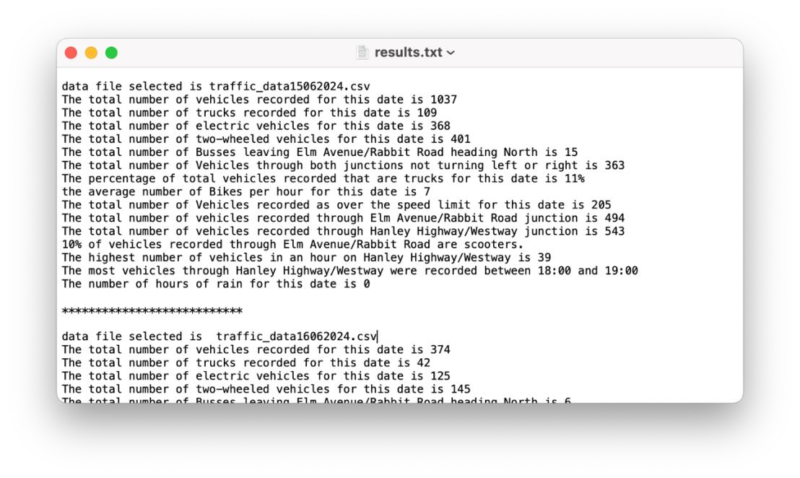
If the user selects run again (Task E: Code loops) with a new date selected, the new output data should be appended to this file.

Task D. Histogram (20 marks)
- The program should use the tkinter module to produce a histogram comparing the volume of traffic (number of vehicles) for each junction by hour for the selected date. The implementation should use a class-based design. A HistogramApp class will encapsulate the entire application, including methods for setting up the Tkinter window, initializing the canvas, drawing the histogram, and dynamically scaling the data. The histogram should include axes, bars, and labels for hours and junctions. The class should take traffic data and the selected date as input parameters, making it flexible and reusable for other datasets. This design ensures modularity and maintainability, with each functionality encapsulated within appropriate methods of the class.The histogram should relate to the data file selected during the program run and work for any volume of vehicles in a selected twenty-four-hour period, it must use the graphics.py module (do not use any other graphing module to complete this section).
- You should include a Title with the correct selected date, a labelled x-axis and a colour legend indicating which colour corresponds to which junction (it doesn’t need to copy the look and colour choice of the example here).

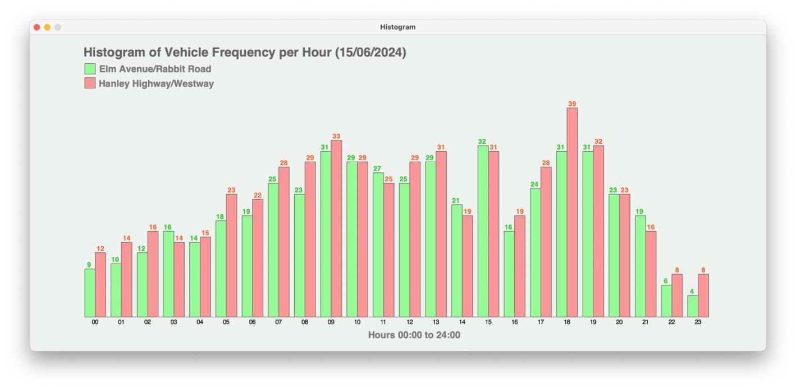

Task E. Code loops to load and processes a new dataset (date) (8 marks)
The program loops to allow a staff member select new data set (CSV) for a different date.

The program should clear data from the previous loop, process the data for different selected dates individually and output the results until the staff member enters ‘N’ to the question “Do you want to select a data file for a different date?”. Optionally, they can use an input of ‘Y’ to continue and load a different CSV file. You should Include code to catch lower case letter input. See example of a single full program run below.

Full Program Run Example (single run, results here are for illustration purposes only)

INPUT
Please enter the day of the survey in the format DD: p
Integer required
Please enter the day of the survey in the format DD: 32
Out of range - value must be in the range 1 to 31.
Please enter the day of the survey in the format DD: 15

Please enter the month of the survey in the format MM: March Integer required
Please enter the month of the survey in the format MM: 13
Out of range - value must be in the range 1 to 12.
Please enter the month of the survey in the format MM: 06
Please enter the year of the survey in the format YYYY: 1997
Out of range - value must lie in the range 2000 to 2024.
Please enter the year of the survey in the format YYYY: 2024
OUTPUT
***************************
data file selected is traffic_data15062024.csv
***************************
The total number of vehicles recorded for this date is 1037
The total number of trucks recorded for this date is 109
The total number of electric vehicles for this date is 368
The total number of two-wheeled vehicles for this date is 401
The total number of Busses leaving Elm Avenue/Rabbit Road heading North is 15
The total number of Vehicles through both junctions not turning left or right is 363
The percentage of total vehicles recorded that are trucks for this date is 11% the average number of Bikes per hour for this date is 7

The total number of Vehicles recorded as over the speed limit for this date is 205
The total number of vehicles recorded through Elm Avenue/Rabbit Road junction is 494 The total number of vehicles recorded through Hanley Highway/Westway junction is 543
10% of vehicles recorded through Elm Avenue/Rabbit Road are scooters.

The highest number of vehicles in an hour on Hanley Highway/Westway is 39
The most vehicles through Hanley Highway/Westway were recorded between 18:00 and 19:00
The number of hours of rain for this date is 0
The program should now pop up a window containing a histogram of results using the graphics.py module (see part D) and save the Task B “Outcomes” output as a text file “results.txt”
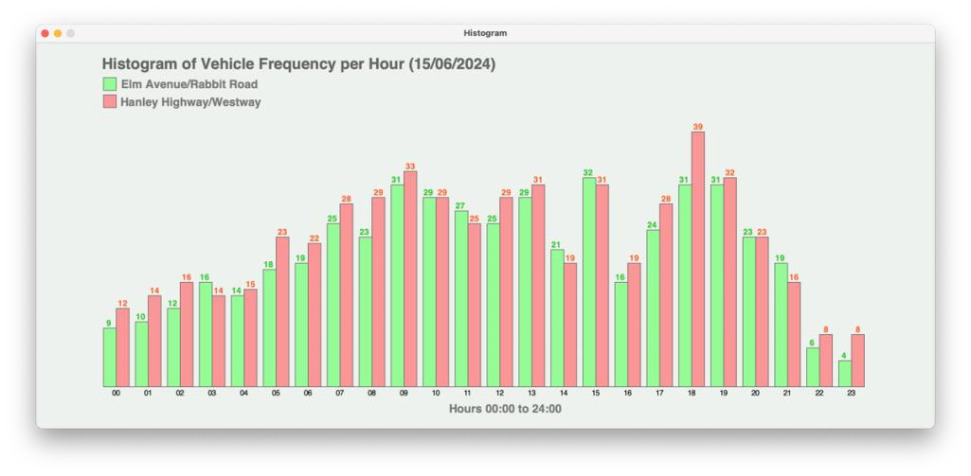
LOOP OR END
Do you want to select another data file for a different date? Y/N > 20
Please enter “Y” or “N” n
End of run

